**ASSIGNMENT 2**

class Dataset {

List<Integer> data = new ArrayList<>();

Set<Integer> ban = new HashSet<>();

void ban(int i) {

ban.add(i);

}

int extendDatasetAndCheckExtraRange(List<Integer> items) {

if (items == null) {

return 0;

}

int min = 0;

int max = 0;

boolean empty = data.isEmpty();

if (!empty) {

min = data.get(0);

max = data.get(0);

}

for (int d: data) {

if (d < min) {

min = d;

} else if (d > max) {

max = d;

}

}

for (int item: items) {

if (!ban.contains(item)) {

data.add(item);

}

}

int extras = 0;

for (int d: data) {

if (empty || d < min || d > max) {

extras += 1;

}

}

return extras;

}

}

**CFG GRAPH:**

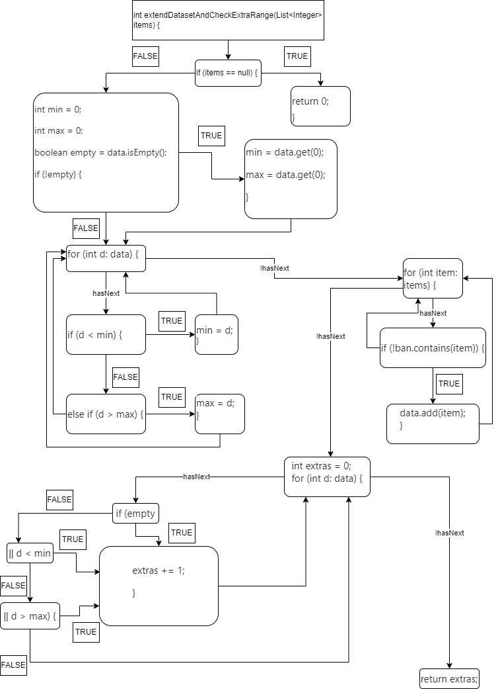

**QUESTION 1:**

In order to get a feasible path that executes the instruction ***extras+=1*** we need to have at least 1 element in ***data***. We also need to have elements in ***items*** which are not banned from ***ban*** and are also already available in ***data***. The last condition we have to meet to make this path feasible is that elements inside ***data*** satisfy the condition of the last for each loop.

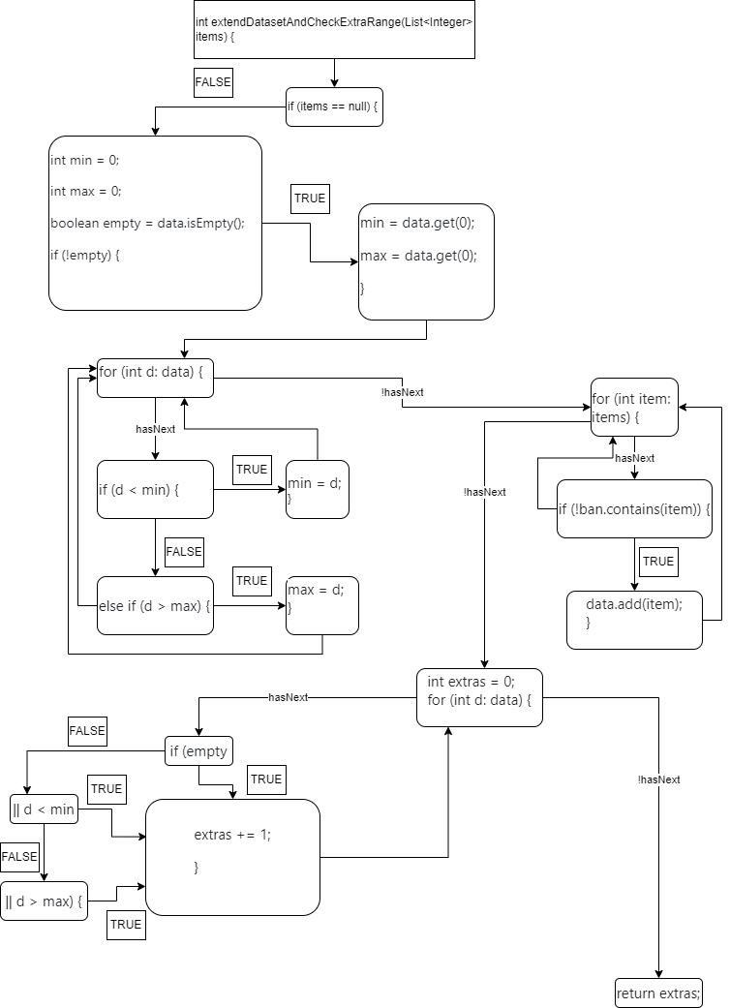

**QUESTION 2:**

In order to get a infeasible path we need to have not met every condition inside the stament: ***if (empty || d < min || d > max) {***

